Name: Akshat Bhargava
Rollno: BEAD-22563
DMV Practical 8
Problem Statement: Analyzing Customer Churn in a Telecommunications
Company

1. Import the "Telecom_Customer_Churn.csv" dataset.
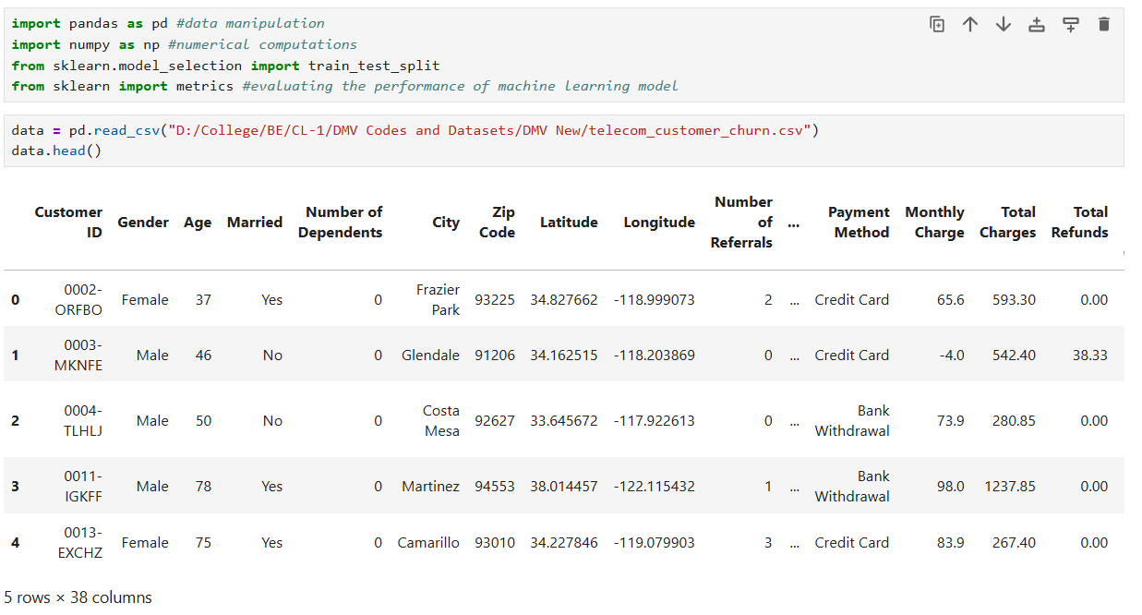

2. Explore the dataset to understand its structure and content.
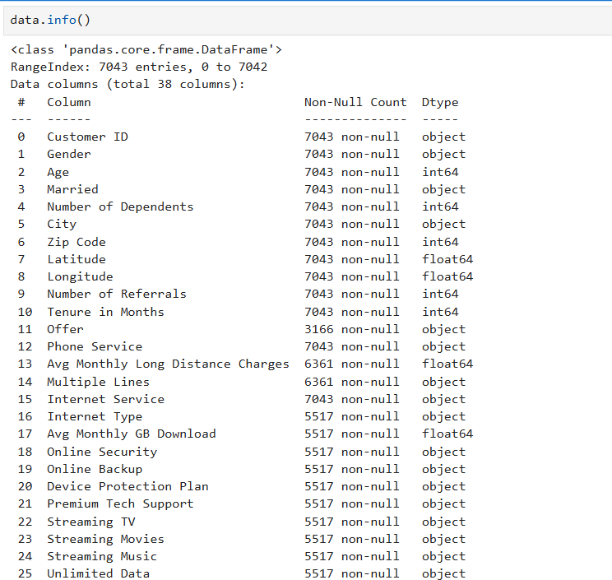
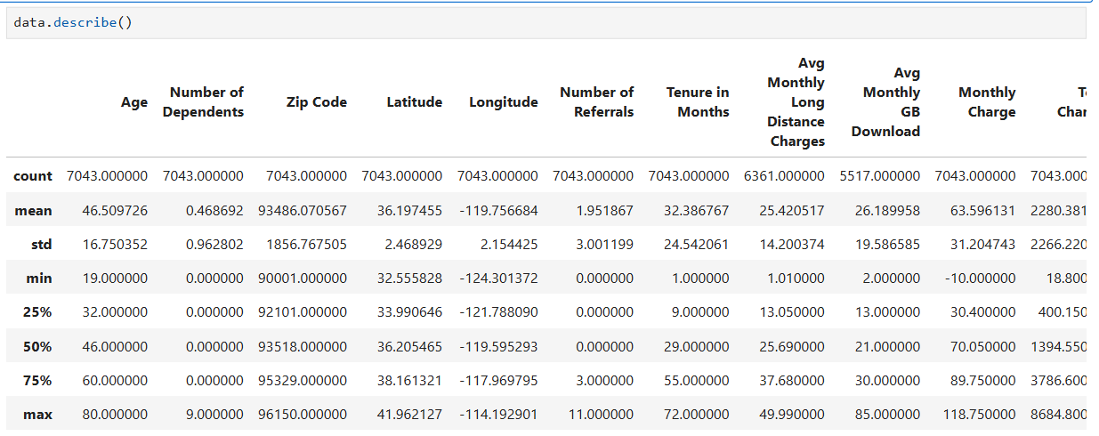

3. Handle missing values in the dataset, deciding on an appropriate strategy.
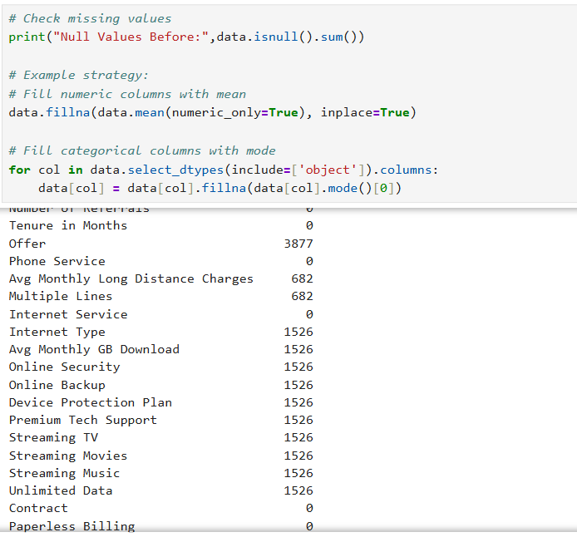
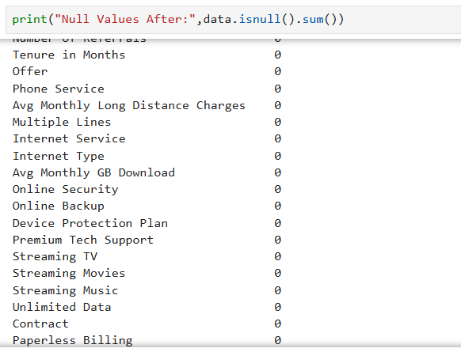

4. Remove any duplicate records from the dataset.
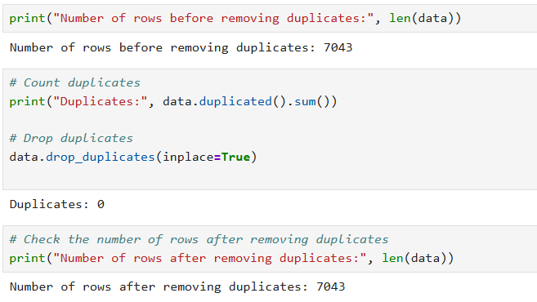

5. Normalize or scale the data if necessary.
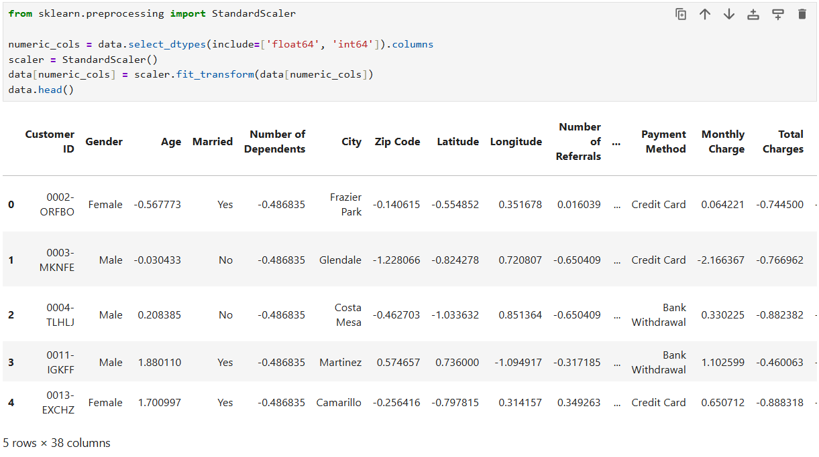

6. Identify and handle outliers in the data.
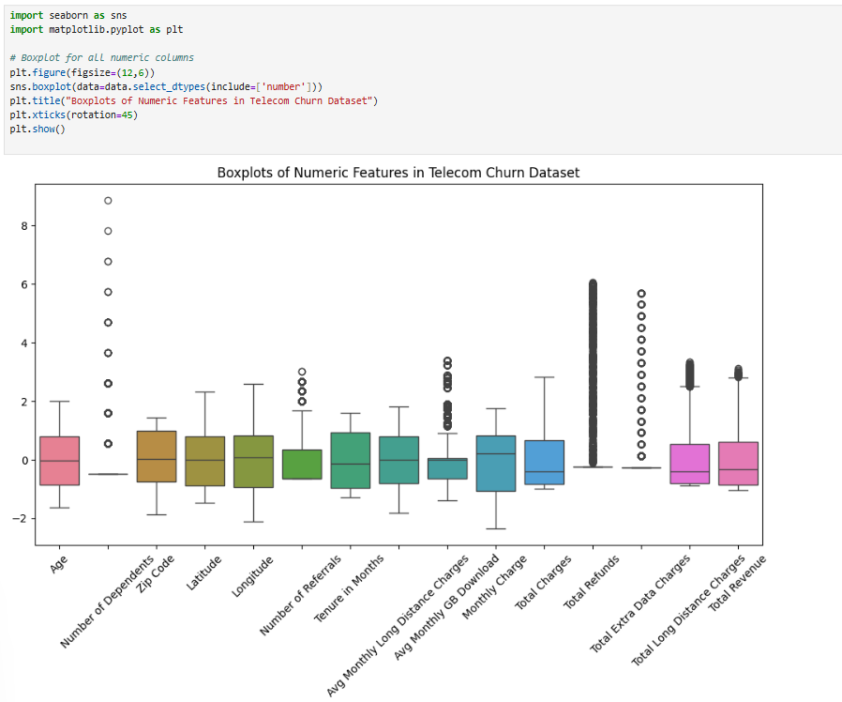
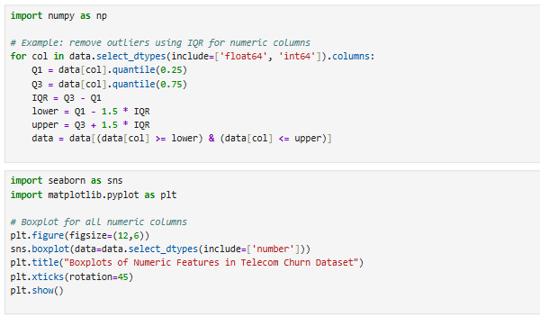
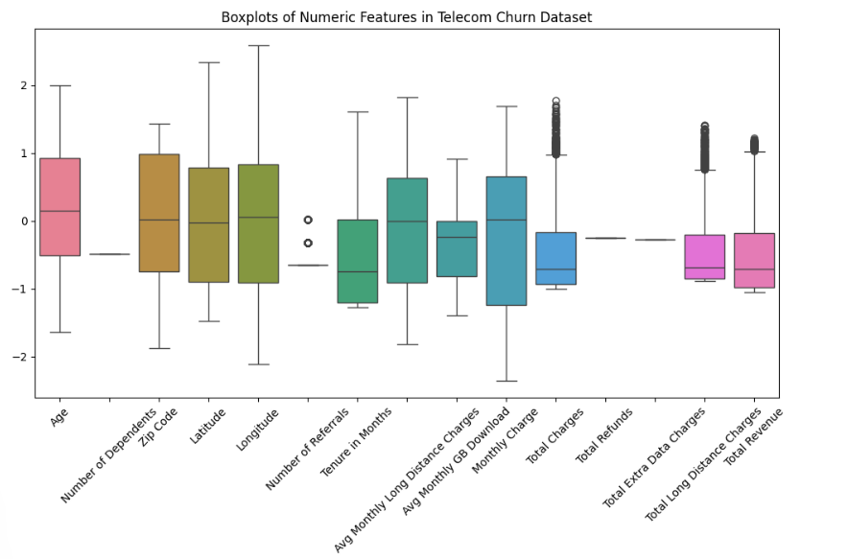
7. Split the dataset into training and testing sets for further analysis.
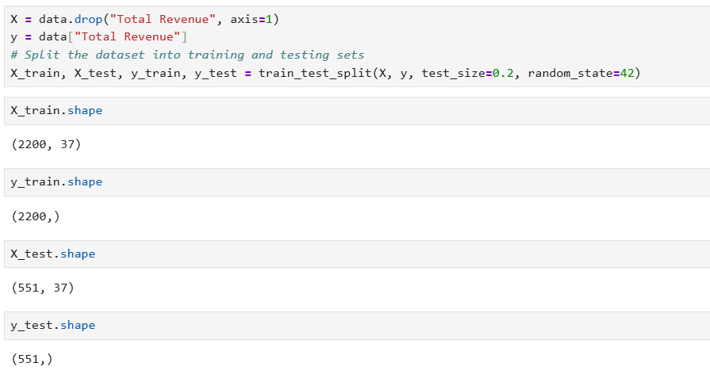

8. Export the cleaned dataset for future analysis or modeling.
